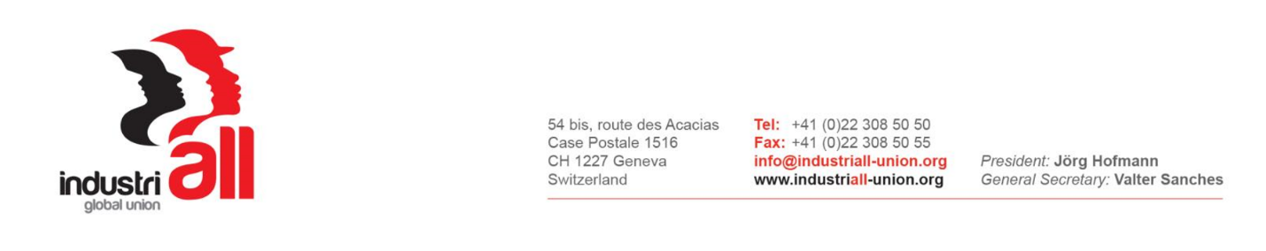

INDUSTRIALL GLOBAL UNION’S
RIO TINTO GLOBAL UNION NETWORK MEETING
19-21 July 2017, Johannesburg, South Africa

CONSOLIDATED ACTION PLAN AND NEXT STEPS

Meeting on the 19 – 21 July 2017 in Johannesburg, South Africa, the IndustriALL Global Union’s Rio Tinto Global Network, adopts the following consolidated action plan and next steps:
- Implementing the Resolution on Recent Developments with the Management of Rio Tinto;
- Encouraging, strengthening and enhancing frequent communication amongst the participants of the Network;
- Consolidating the collective bargaining research and implement recommendations of the research report towards the goal of a common collective bargaining strategy. This will entail identifying low hanging fruits such as:

- Putting a greater and urgent focus on contracting and precarious work by organizing contractors and identifying progressive language on contractors for inclusion in Collective bargaining agreements;
- Identifying minimum economic and social benefits for inclusion as demands in collective bargaining agreements at the point of negotiating cycles;
- Synchronising as practically possible collective bargaining cycles.
- Continuing with the global mapping and profiling of both Rio Tinto company and Global Union Network affiliates, as global mapping is a continuous ongoing activity of the global network;
- Sending country reports as presented at the meeting to IndustriALL Global Union in the agreed country report template in order to standardise reporting and data collecting within a timeline not exceeding a month from this meeting;
- Consolidating the collection of data by requesting relevant needed data from Rio Tinto on, for instance, worker employment figures, disaggregated with regard to permanent and contractors, diversity in respect of gender, unionised versus non-unionised, wage data across employment categories, etc;
- Facilitating by IndustriALL Global Union a global fact finding mission to Madagascar due to the unacceptable working conditions experienced by Malagasy workers at Rio Tinto and Rio Tinto to be requested to participate in the fact finding mission;
- Escalating the occupational health dimension of our work on health and safety, with particular reference to occupational respiratory diseases. In this regard, initiate campaigns similar to the CFMEU’S campaign on the black lung re-emergence in Australian coalmines to highlight the devastating consequence of non-compliance by the mining industry;
- Demanding to co-design and participate in inspections and monitoring protocols;
- Contesting the International Employers Organisation and national standardization bodies undue influence on the ILO concerning the uncritical acceptance of the ISO standards, particularly the one called ISO45001;
- Continuing to build trade union power through recruitment and organizing with a particular focus on contractors and precarious work;
- Implementing structured learning and training in all areas of our work, such as in the training of health and safety representatives, collective bargaining, recruitment and organizing, etc.;
- Continuing to focus on gender equity across Rio Tinto’s global operations to address women discrimination and to encourage the setting up of constitutional women structures within our unions;
- Fostering and encouraging unity and collaboration within national trade unions and to facilitate solidarity within and across borders at Rio Tinto operations;
- Encouraging youth recruitment and participation within the global network.

