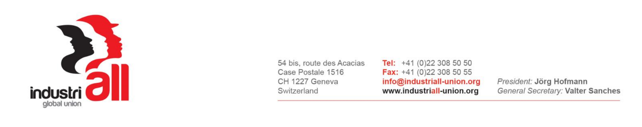

INDUSTRIALL GLOBAL UNION’S
RIO TINTO GLOBAL UNION NETWORK MEETING
19-21 July 2017, Johannesburg, South Africa

RESOLUTION ON RECENT DEVELOPMENT WITH A CONSTRUCTIVE DIALOGUE WITH THE MANAGEMENT OF RIO TINTO

Meeting on the 19 – 21 July 2017 in Johannesburg, South Africa, the IndustriALL Global Union’s Rio Tinto Global Network, acknowledges the good progress made in discussions/negotiations with the management of Rio Tinto, and notes the commitments contained in the letter dated 11 April 2017 from the Company to representatives of the Network Steering Committee.

The participants declare that the Network endorses the process outlined in that letter, and as further confirmed and clarified by Rio Tinto Head of Employee Relations, Rick Willmott at the Network meeting.

The meeting congratulates the leadership group for their efforts in bringing our global campaign to this result, but also acknowledge that the Network must remain vigilant to ensure the commitments we have received are put into place.

The Network undertakes to continue to share information throughout the participants; to report non-compliance with the confirmed principles and agreed processes; and to re-energize the global campaign at short notice if required.

The Network also undertakes to continue and expand solidarity activities, where necessary, to support workers and unions across the Network in their struggles with Rio Tinto.

In conclusion, and in light of the progress made, the Network agrees to be guided by the Steering Committee as to the requirement to reconvene for any future face-to-face meeting of the Network.

