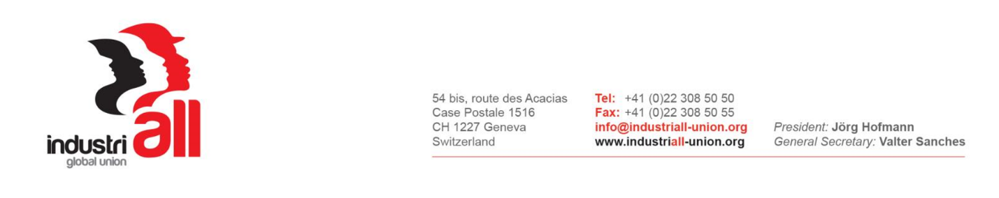

INDUSTRIALL GLOBAL UNION’S
RIO TINTO GLOBAL UNION NETWORK MEETING
19-21 July 2017, Johannesburg, South Africa

RESOLUTION ON SOLIDARITY WITH WORKERS IN THE ONGOING STRIKE AT GRASBERG MINE IN INDONESIA

Meeting on the 19 – 21 July 2017 in Johannesburg, South Africa, the IndustriALL Global Union’s Rio Tinto Global Network, noting the dismissal of more than 4,000 workers at Grasberg mine in Indonesia controlled by PT Freeport-McMoRan, the local subsidiary of Phoenix, a USA-based Freeport-McMoRan, in which Rio Tinto has a 40% stake, resolve as follows:

The Network condemns the unjustified and unlawful dismissal of the more than 4.000 workers organized by IndustriALL Global Union’s affiliate Chemical, Energy and Mines Workers Union (CEMWU SPSI PTFI) at Grasberg Mine and FSPMI (Federation of Indonesian Metal Workers' Union) at PT Smelting, a joint venture between Freeport-McMoRan and Mitsubishi Materials that processes copper from Grasberg.
The Network supports the multiple efforts taken by IndustriALL Global Union in solidarity with the dismissed mine workers, calling on PT Freeport-McMoRan and the Indonesian Government to end the dispute and to ensure the reinstatement of the dismissed workers. These efforts include:
- An IndustriALL LabourStart global campaign;
- Meetings with the Indonesian delegation at the recently concluded International Labour Conference of the ILO;
- Letters of protest to Freeport-McMoRan Inc. in the USA, and to the government of Indonesia;
- The many solidarity letters by the mining and metals affiliates of IndustriALL Global Union;
- The soon to be taken high-level solidarity mission to Indonesia by IndustriALL Global union’s affiliates in the mining and metals sector.
IndustriALL Global Union’s Rio Tinto Global Network stands in solidarity with the dismissed workers at PT Freeport-McMoRan and PT Smelting and call on the Government of Indonesia to order PT Freeport-McMoRan and PT Smelting to comply with the labour laws of Indonesia.

